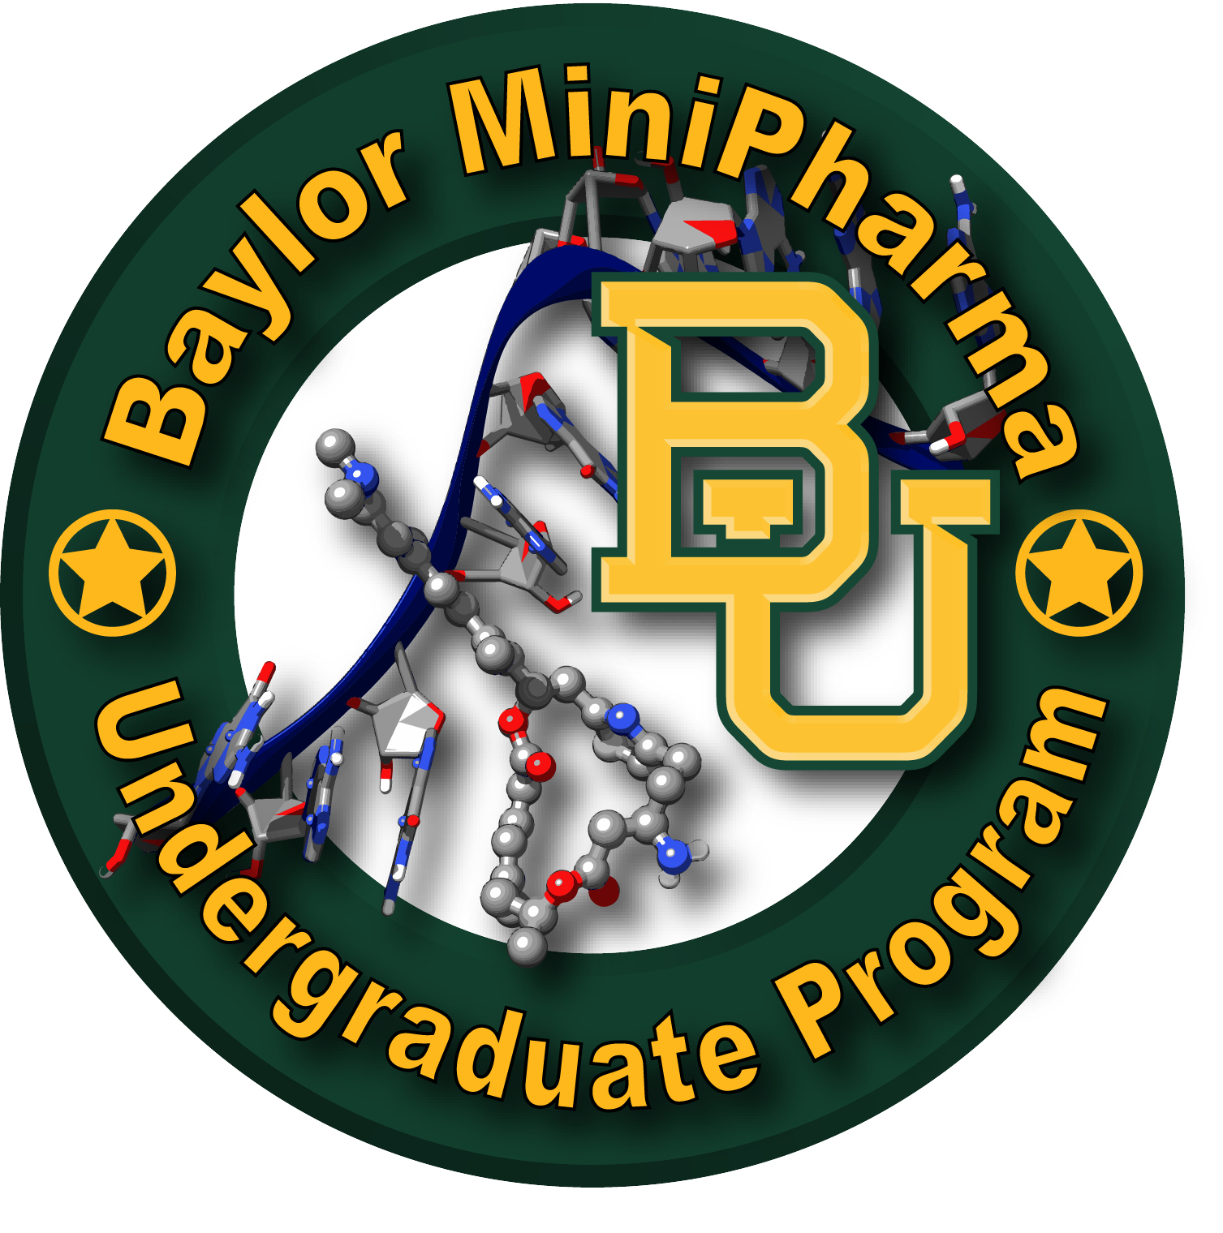
Baylor Undergraduate MiniPharma Application
(PI’s: Profs. D. Romo & J. Taube; Dr. Ken Hull)
(Submit a PDF version of this document to: Daniel_Romo@baylor.edu & Kenneth_Hull@baylor.edu, Aimee_Moraitis@baylor.edu)

Date: _______________

Name* _________________ ______ _____________________
First Name Middle Initial

Last Name

E-mail* ________________________________
example@baylor.edu

Phone Number: _______-_______-___________

GPA: ______ Major: ____________

Planned Semester & Year for Graduation: ________________

Are you willing and able to devote at least 2 years including 1 full Summer to the MiniPharma Program? Yes / No ?

Please list provide your final grade and professor(s) for CHE 3331 & 3332:

CHE3331: Sem/Yr Taken? _______Grade: ____ & Prof: ______________
CHE3332: Sem/Yr Taken? _______Grade: ____ & Prof: ______________

Have You Taken CHE 3238 Organic Laboratory?
-Please Include Grade (letter): ____

Have You Taken CHE 4237 Advanced Organic Laboratory?
-Please Include Grade (letter): ____& Professor: ____________

List any computer software/database/etc. experience:

Please describe what led you to apply to MiniPharma and why you want to be a part of the MiniPharma Program:

Please describe your primary career goals:

Please describe any past research experience or other experiences that may be directly relevant to MiniPharma research:

